**Benjamín Valdez Rodríguez**

**A00822027**

**Código**

//

// main.c

// P8 Data Union

//

// Created by Benjamín Valdez on 3/12/20.

//

#include <stdio.h>

#include <float.h>

#include <string.h>

**union** Data {

**int** unionInt;

**float** unionDouble;

**char** unionString[101];

};

**int** main(**int** argc, **const** **char** * argv[]) {

**union** Data inputs;

**int** input1 = 0;

**char** input2 = ' ';

**double** input3 = 0;

printf("Give me a integer: ");

scanf("%d", &input1);

inputs.unionInt = input1;

printf("Your integer <%d> storage size is <<%lu>> bytes\n", input1, **sizeof**(input1));

printf("Give me a double: ");

scanf("%lf", &input3);

inputs.unionDouble = input3;

printf("Your double <%f> storage size is <<%lu>> bytes, I can read any number from <<%f>> to <<%f>> in this data type.\n", input3, **sizeof**(input3), DBL_MIN, DBL_MAX);

printf("Give me a char: ");

scanf("%s", &input2);

strcpy(inputs.unionString, &input2);

printf("Your char <%c> storage size is <<%lu>> bytes. And I can read it as <<%c>> or as <<%d>>\n", input2,**sizeof**(input2), input2, input2);

**return** 0;

}

**Caso de Prueba 1**

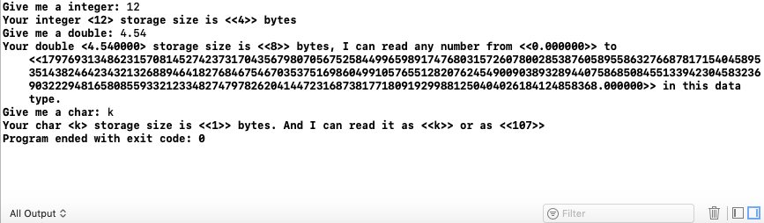

**Caso de Prueba 2**

